Ex.no:8 | MINI PROJECT – CREDIT CARD FRAUD DATA ANALYTICS

Domain and Problem Statement:
Domain: Financial Data Analytics
Problem Statement: Financial institutions process a large volume of credit card transactions, making manual fraud detection difficult. This project transforms raw credit card transaction data into structured and usable information. Fraudulent transactions can cause significant financial losses and security risks. Python is used for data cleaning, MySQL for data storage, and Power BI and Tableau for visualization. The analysis focuses on transaction volume, fraud rate, fraud trends, transaction amounts, and time-based fraud patterns.
Dataset Description:
Dataset Name: Credit Card Fraud Detection Dataset
Granularity: Each row represents a single credit card transaction.
Dataset Size: 284,807 transactions
Number of Attributes: 31
Key Entities & Attributes:
Transaction Information:
• Time – Seconds elapsed between the first transaction and the current transaction.
• Amount – Amount involved in the transaction.
Anonymized Features:
V1 to V28 – PCA-anonymized numerical features representing transaction characteristics.
Target Attribute:
Class
- 0 – Legitimate transaction
- 1 – Fraudulent transaction
Data Source:
Primary Source: Kaggle – Credit Card Fraud Detection Dataset
Input File: Credit card transaction dataset
Data Processing Tool: Python / Jupyter Notebook
Database: MySQL
Database Name: fraud_analytics
Table Name: transactions
Visualization Tools:
- Power BI
- Tableau
Architecture:
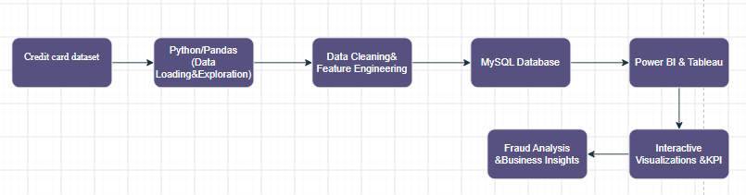
Program:
1. Python – Data Cleaning & Transformation
import pandas as pd

# Load dataset
file_path = "creditcard.csv"
df = pd.read_csv(file_path)
#Dataset Dimensions
print("Rows:", df.shape[0])
print("Columns:", df.shape[1])
#View First 5 Records
df.head()

# Create a copy for processing
cc = df.copy()
# Missing Value Check
print("Missing values per column:\n", cc.isnull().sum().sum())

# Duplicate Removal
before = cc.shape[0]
cc.drop_duplicates(inplace=True)
print(f"Removed {before - cc.shape[0]} duplicate rows")

2. Feature Engineering
#Transaction Hour
cc["transaction_hour"] = ((cc["Time"] // 3600) % 24).astype(int)
# Transaction Day
cc["transaction_day"] = (
(cc["Time"] // (3600 * 24)).astype(int) + 1
)
# Amount Category
cc["amount_category"] = pd.cut(
cc["Amount"],
bins=[-0.01, 10, 50, 200, 1000, cc["Amount"].max()],
labels=["<10", "10-50", "50-200", "200-1000", "1000+"]
)
# Fraud Label
cc["fraud_label"] = cc["Class"].map({
0: "Legitimate",
1: "Fraud"
})
# Standardize Column Names
cc.columns = (
cc.columns
.str.lower()
.str.strip()
.str.replace(" ", "_")
)
# Validate Transaction Amount
cc = cc[cc["amount"] >= 0]
3. Fraud Class Distribution
#Transactions analysed
print(cc["fraud_label"].value_counts())
print(
cc["fraud_label"].value_counts(normalize=True) * 100
)
4. MySQL – Database and Data Loading
# Required Libraries
from sqlalchemy import create_engine, text
from urllib.parse import quote_plus
# MySQL Connection
username = "root"
password = "YOUR_MYSQL_PASSWORD"
host = "127.0.0.1"
port = 3306
# Create Database
server_engine = create_engine(
f"mysql+pymysql://{username}:{safe_password}@{host}:{port}"
)
with server_engine.connect() as connection:
connection.execute(
text("CREATE DATABASE IF NOT EXISTS fraud_analytics")
)
print("Database created/exists.")
# Connect to Database
db_engine = create_engine(
f"mysql+pymysql://{username}:{safe_password}@{host}:{port}/fraud_analytics"
)
print("Connected to fraud_analytics!")
# Load Data into MySQL
cc.to_sql(
"transactions",
con=db_engine,
if_exists="replace",
index=False,
chunksize=5000
)
print("Data loaded successfully!")
5.SQL Data Verification
pd.read_sql(
"SELECT COUNT(*) AS total_rows FROM transactions",
db_engine
)
pd.read_sql(
"SELECT * FROM transactions LIMIT 5",
db_engine
)
6. KPI Calculation
summary = pd.read_sql("""
SELECT
COUNT(*) AS total_transactions,
SUM(class) AS total_fraud_cases,
ROUND(
100 * SUM(class) / COUNT(*), 4
) AS fraud_rate_pct,
ROUND(AVG(amount), 2)
AS avg_transaction_amount,
ROUND(SUM(amount), 2)
AS total_transaction_volume
FROM transactions
""", db_engine)
summary
Procedure:

Step 1: Data Loading and Preparation – Python / Jupyter Notebook
- Open Jupyter Notebook and create a new Python notebook.
- Import the required Python libraries such as Pandas, NumPy, Matplotlib, and Seaborn.
- Load the credit card transaction dataset into the notebook using Pandas.
- Display the dataset shape to identify the number of records and attributes.
- Display the first few records using head() to understand the structure of the dataset.
- Check the dataset for missing values.
- Check for duplicate transaction records.
- Remove duplicate records from the dataset to avoid repeated transactions.
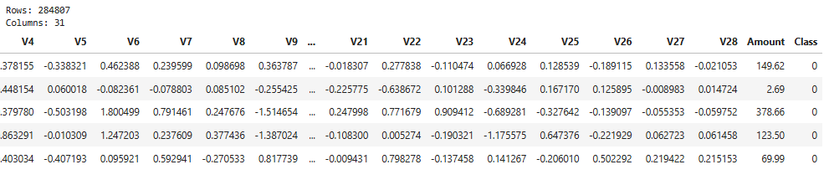

Step 2: Data Cleaning and Transformation
- Create a copy of the original dataset for preprocessing.
- Validate the transaction amount values and remove invalid negative amounts where applicable.
- Standardize the column names by converting them into a consistent format.
- Separate the target variable Class from the transaction features.
- Verify the distribution of the Class variable.
- Identify:
  - Class = 0 → Legitimate transaction
  - Class = 1 → Fraudulent transaction
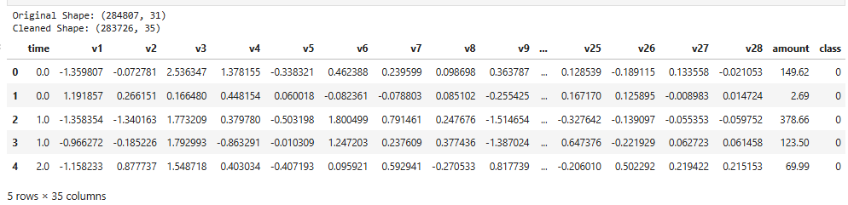

Step 3: Feature Engineering
- Create Transaction Hour from the Time column.
- Create Transaction Day from the Time column.
- Create Amount Category by grouping transaction amounts into different ranges.
- Create Fraud Label by converting the numerical Class values into readable labels:
  - 0 → Legitimate
  - 1 → Fraud
- Verify the newly created columns and display the processed dataset.
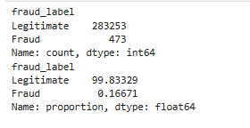

Step 5: MySQL Database Creation and Data Loading
- Install and start the MySQL Server.
- Create a database named: fraud_analytics
- Connect the Python/Jupyter Notebook to MySQL using SQLAlchemy.
- Load the cleaned and transformed dataset into MySQL.
- Store the data in a table named: transactions.
- Verify the number of records stored in the MySQL table using an SQL query.
- Display a few records from the database to confirm successful data loading.
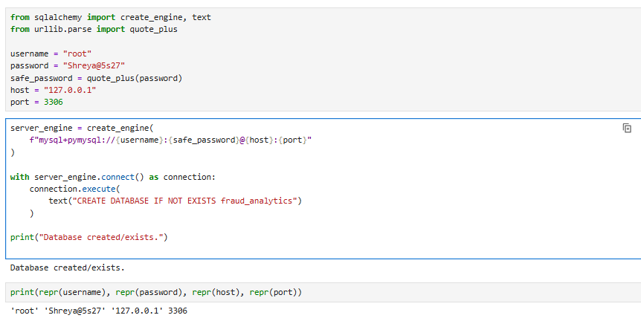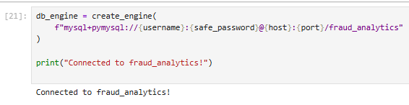
Step 6: SQL Database Connection & Data Ingestion
- Open Power BI Desktop $→$ Click Get Data $→$ Select MySQL Database.
- Enter the Server (localhost:3306) and Database Name (fraud_analytics).
- Enter authentication credentials, select the cleaned flat table (hotel_bookings / hotel_analytics), and click Transform Data to open Power Query
- 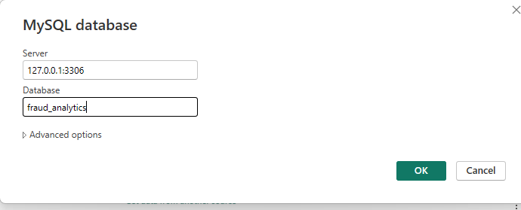
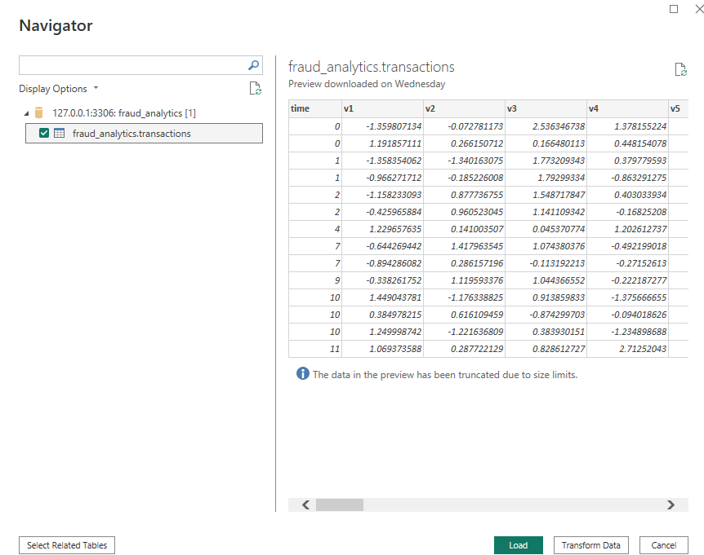
Step 6: Charts
Fraud by Transaction Hour:
• Click Report view.
• Select Clustered column chart.
• Drag transaction_hour → X-axis.
• Drag Class → Y-axis / Values.
• In the Class field dropdown, choose Sum
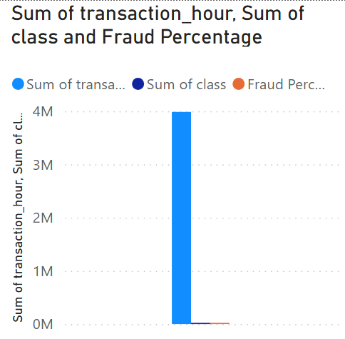
Fraud by Transaction Day:
- Select Clustered column chart.
- Drag transaction_day → X-axis.
- Drag Class → Y-axis / Values.
- Keep it as Sum.
- 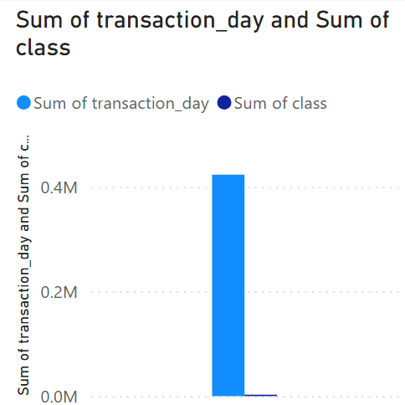
Create Total Transactions:
Fraud Cases by Amount Category:
• Click a blank area on your Power BI report.
• Select Clustered column chart.
• From the Fields pane, drag amount_category → X-axis.
• Drag class → Y-axis / Values.
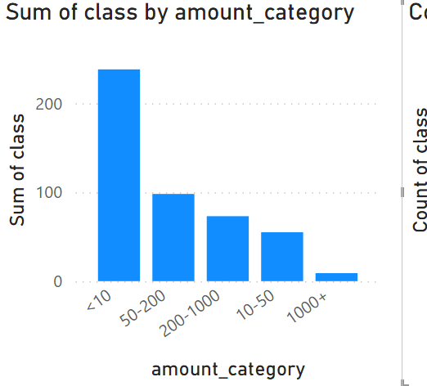
Fraud Trend by Transaction Day:
• Click a blank area on the report.
• Select Line chart.
• Drag transaction_day → X-axis.
• Drag class → Y-axis / Y-axis values.
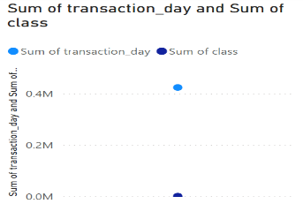
Fraud vs Legitimate:
• Click a blank area on the report.
• Select the Donut chart icon.
• Drag fraud_label → Legend.
• Drag class → Values.
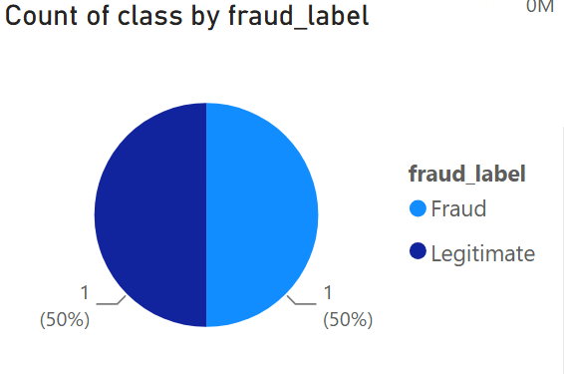
Create Fraud Percentage:
Fraud Percentage by Amount Category:
• Click a blank area.
• Select Clustered column chart.
• Drag amount_category → X-axis.
• Drag Fraud Percentage → Y-axis.
• Select the measure → Format → Percentage.
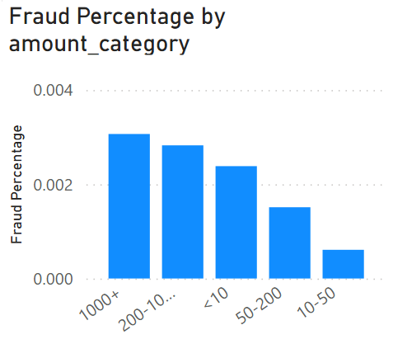
3 KPI cards:
Fraud Cases by Transaction Hour:
• Click a blank area on the report.
• Select the Card visual.
• Drag class → Data/Fields.
• Change the aggregation from Sum if needed so it shows the total fraud cases.
- Since class = 1 is fraud, Sum of class = number of fraud cases.
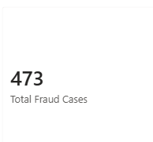
Total Transactions Card:
• Select a Card visual.
• Drag class into the Card's Data/Fields area.
• Click the dropdown beside class.
• Select Count.
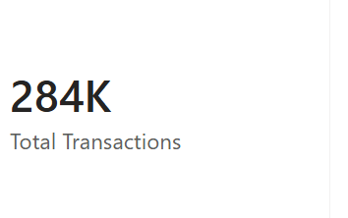
Total Transaction Amount:
• Click a blank area on the report.
• Select Card.
• Drag amount → Data/Fields.
• Make sure the aggregation is Sum.
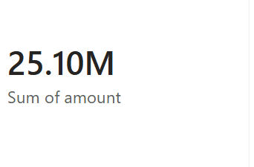

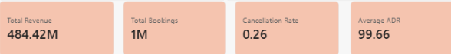
Step 5: Power BI Final Executive Dashboard & Drill-Through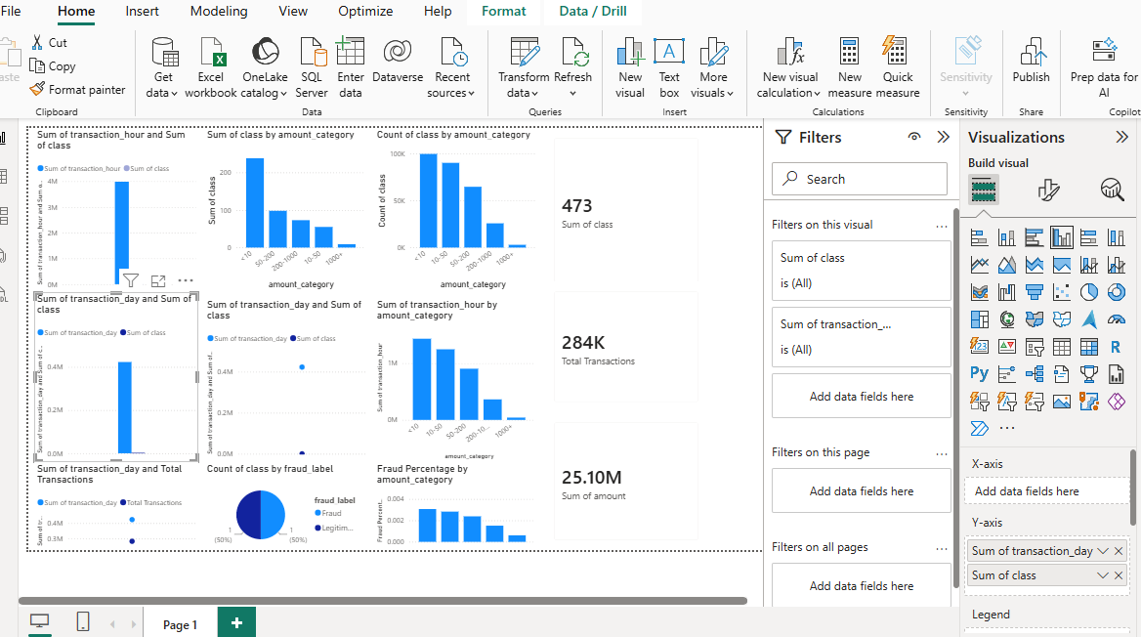

Step 6: Tableau Data Connection & Preparation
- Open Tableau Desktop / Tableau Public.
- Under To a Server, select MySQL
- Enter Server (localhost), Database (fraud_analytics), and user credentials to pull the cleaned dataset onto the canvas.
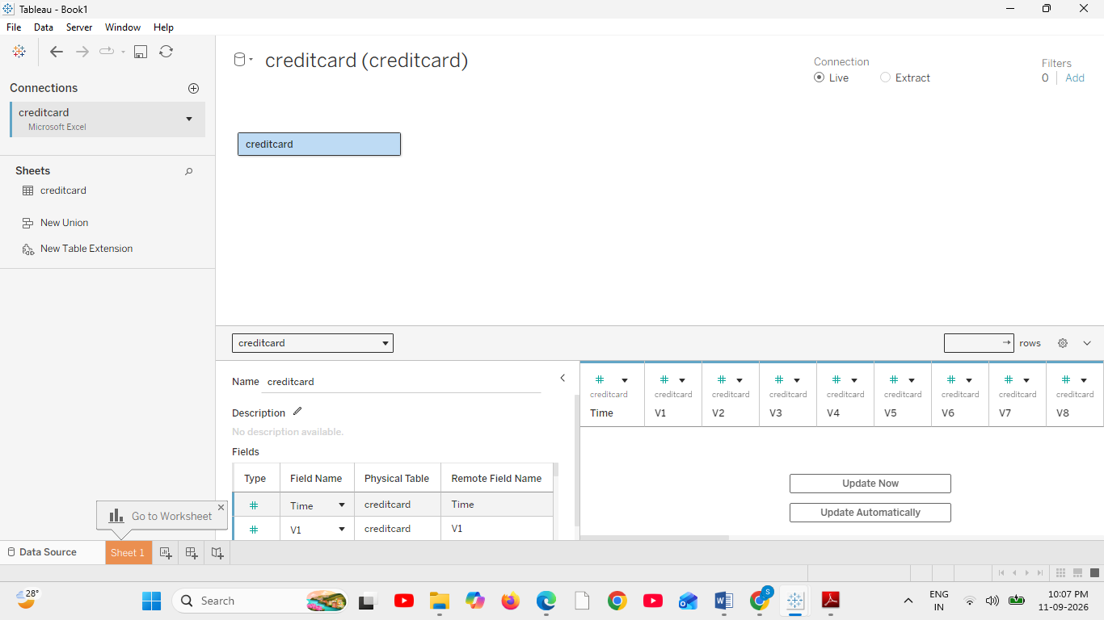
Go to any sheet and build calculated fields:
- Transaction Type
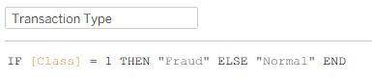
- Hour of Day
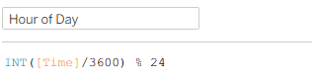
- Amount Bucket
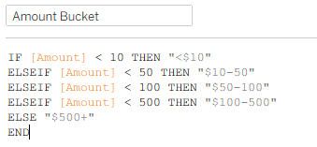

- Build the KPI sheet
• Drag Total Amount, Total Transactions, Fraud Count, and Fraud Rate (all four calculated fields) onto the Text box on the Marks card, one at a time
• Tableau automatically creates a Measure Names / Measure Values structure — you'll see "Measure Names" appear on Rows or Columns
• Click the Show Me panel (top right) → choose Text Table, or just leave it as a single row
Displays four headline metrics — Total Amount, Total Transactions, Fraud Count, Fraud Rate — using Tableau's Measure Names / Measure Values mechanism on a single sheet.
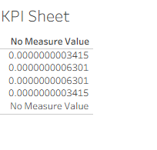
- Build the Fraud vs Normal bar chart
• Drag Transaction Type to Rows
• Drag Average Amount to Columns
• Drag Transaction Type onto Color on the Marks card (this colors the two bars differently)
• Tableau will auto-pick a bar chart since one field is a dimension and one is a continuous measure
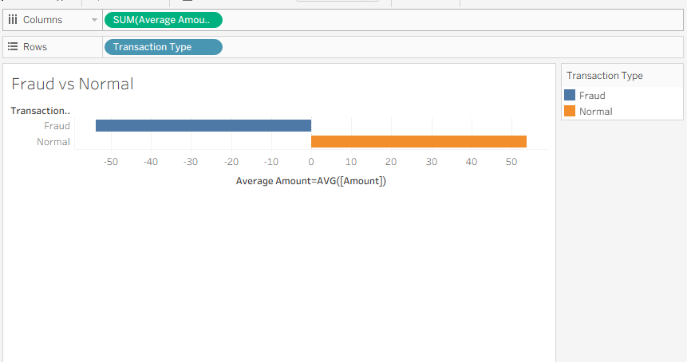

Hourly Trend:
• Drag Hour of Day to Columns → right-click the pill → set to Dimension and Continuous (so it draws as a smooth line, not discrete bars)
• Drag Fraud Rate (or any metric) to Rows
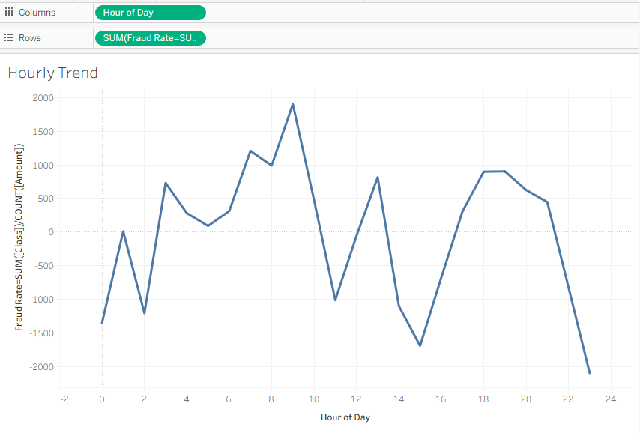
Fraud Heatmap:
• Amount Bucket → Rows
• Hour of Day (continuous) → Columns
• Fraud Rate → Color (drag onto Marks card, or onto Color directly)
• Fraud Count → Label (so each cell shows a number, not just a color)
• Change Marks type dropdown (top-left of Marks card) to Square for a clean grid look.
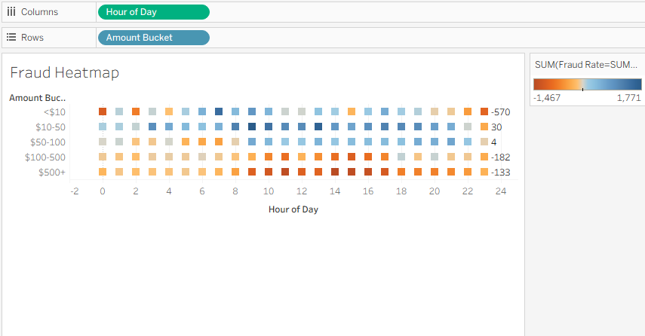
Dashboard:
• KPI Sheet — top strip
• Fraud Heatmap and Fraud vs Normal — middle row, side by side
• Hourly Trend — bottom row
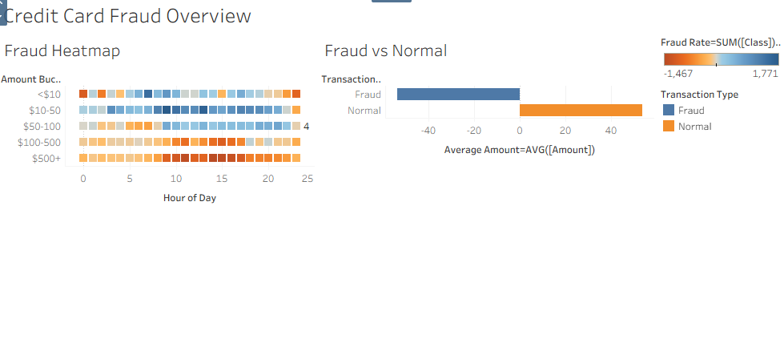
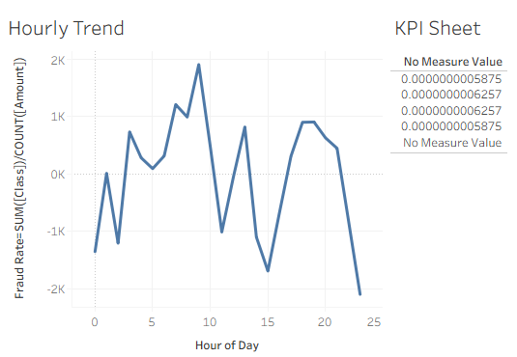
Key Insights:
The combination of the heatmap and hourly trend reveals when and at what amount fraud is most concentrated, while the KPI sheet gives a fast summary of overall fraud exposure — replicating the analytical role a geographic map plays in datasets that do have location data, adapted to a dataset where time and amount are the meaningful dimensions instead.
• Transaction Volume & Value: The dataset captures 284.8K Total Transactions generating $25.16M in gross transaction value, with an Average Transaction Amount of $88.35.
• Fraud Rate: The portfolio reflects a 0.17% Fraud Rate (492 of 284,807 transactions), with fraudulent transactions averaging $122.21 versus $88.29 for normal transactions — roughly 38% higher on average.
• Time-of-Day Risk Pattern: Transaction volume peaks at 9 PM (17.7K transactions) and bottoms out at 4 AM (2.2K transactions), but fraud risk tells a different story — it spikes at 2 AM, where the fraud rate hits 1.71%, nearly 10x the portfolio average.
• Amount-Based Risk Distribution: Risk isn't linear with transaction size — fraud concentrates at both extremes, with transactions over $500 showing the highest fraud rate (0.38%), followed by transactions under $10 (0.25%), while the $10–$50 range is the safest tier at just 0.06%.

